00-课堂汇报任务（11.30、12.05）

# 课堂汇报要求：

* **每组3人，选择感兴趣的主题和一篇论文进行阅读，也可以根据下列主题自己找一篇CCF-A类会议或期刊论文**
* **课堂汇报25分钟，包括论文讲解20分钟，回答问题5分钟**
* **评分依据：**
  + **论文讲解完整程度，对于论文的研究动机、研究背景、所提出方法、创新点、实验结果等讲述是否清晰**
  + **汇报PPT的内容和排版是否合理**
  + **是否能流畅回答对于技术方面的提问**

**请填写下面分组和汇报主题/论文的选择：**

|  |  |  |
| --- | --- | --- |
| **主题** | **论文题目** | **组员（每组成员3人）** |
|  |  |  |
|  |  |  |
|  |  |  |
|  |  |  |
|  |  |  |
|  |  |  |
|  |  |  |
|  |  |  |

# Topic 1. Modeling

* (Sketch-to-CAD Modeling) Changjian Li, Hao Pan, Adrien Bousseau, Niloy J. Mitra: Free2CAD: parsing freehand drawings into CAD commands. ACM Trans. Graph. 41(4): 93:1-93:16 (2022)

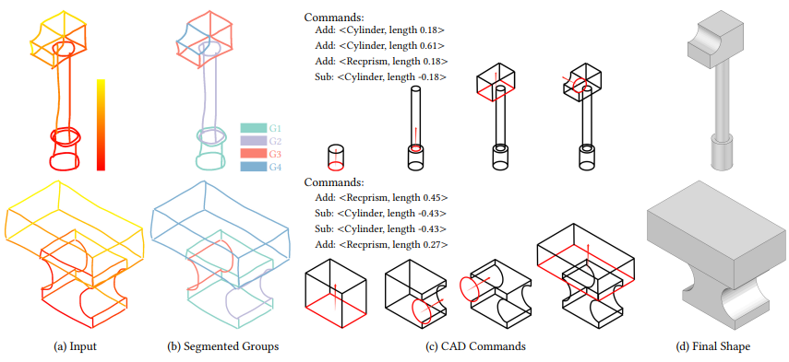

* (2DSketch-to-3DSketch) Felix Hähnlein, Yulia Gryaditskaya, Alla Sheffer, Adrien Bousseau: Symmetry-driven 3D Reconstruction from Concept Sketches. SIGGRAPH (Conference Paper Track) 2022: 19:1-19:83)

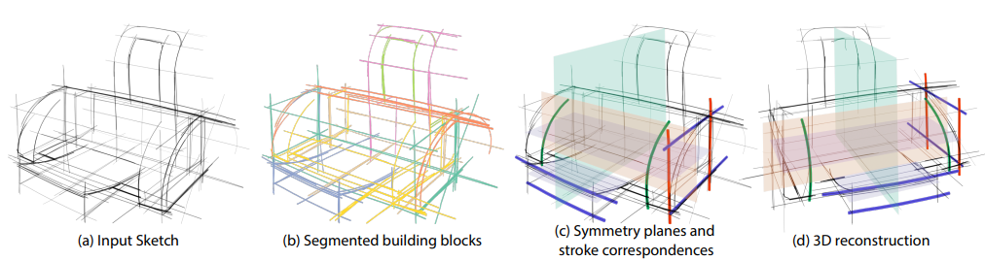

* (3D Reconstruction from a Large Image Set) Jiaming Sun, Xi Chen, Qianqian Wang, Zhengqi Li, Hadar Averbuch-Elor, Xiaowei Zhou, Noah Snavely: Neural 3D Reconstruction in the Wild. SIGGRAPH (Conference Paper Track) 2022: 26:1-26:9

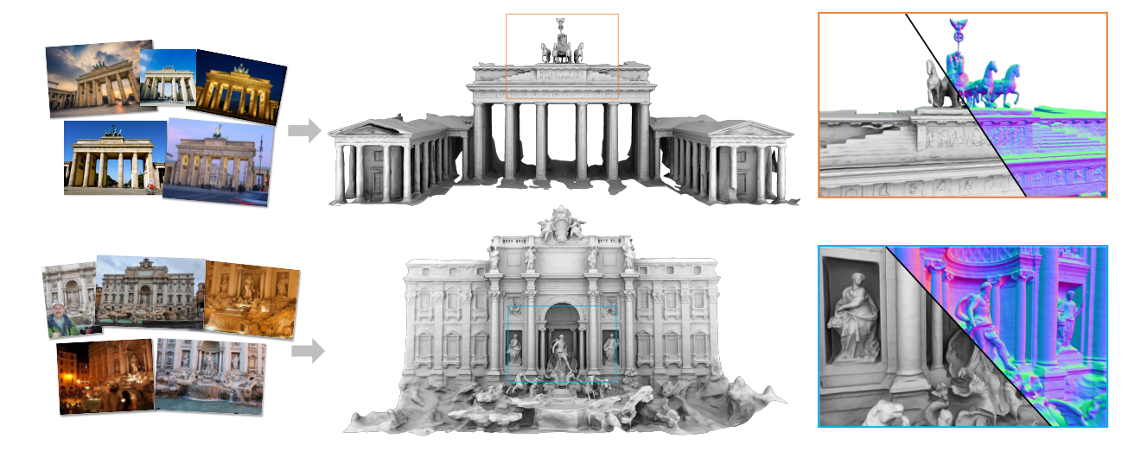

* (Shape Editing) Amir Hertz, Or Perel, Raja Giryes, Olga Sorkine-Hornung, Daniel Cohen-Or: SPAGHETTI: editing implicit shapes through part aware generation. ACM Trans. Graph. 41(4): 106:1-106:20 (2022)

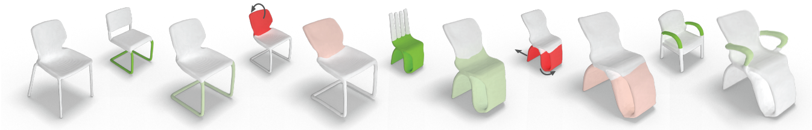

* (Material Transfer) Ruizhen Hu, Xiangyu Su, Xiangkai Chen, Oliver van Kaick, Hui Huang: Photo-to-shape material transfer for diverse structures. ACM Trans. Graph. 41(4): 131:1-131:14 (2022)

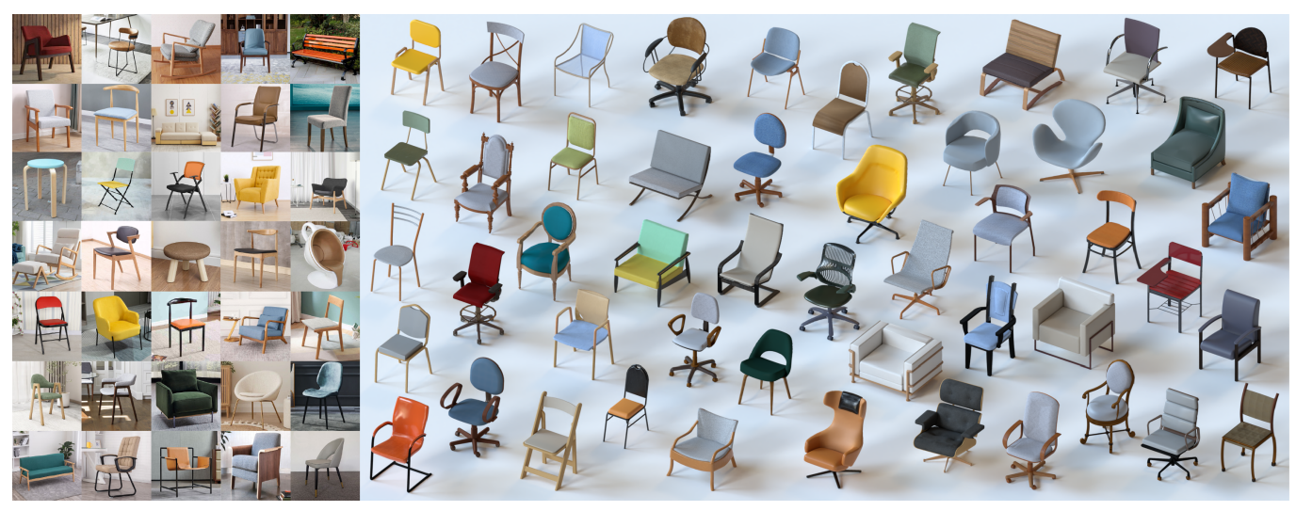

* (Improving MarchingCubes with Neural Network) Zhiqin Chen, Hao Zhang: Neural marching cubes. ACM Trans. Graph. 40(6): 251:1-251:15 (2021)

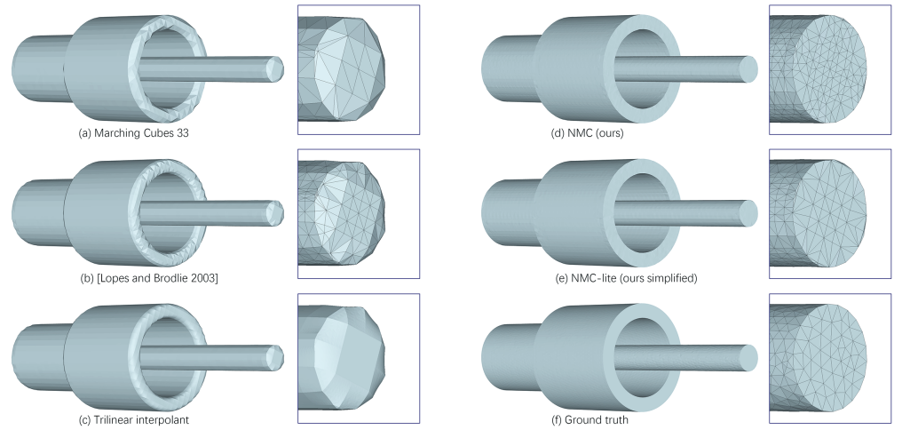

* (Point Cloud to CSG Representation) Fenggen Yu, Zhiqin Chen, Manyi Li, Aditya Sanghi, Hooman Shayani, Ali Mahdavi-Amiri, Hao Zhang: CAPRI-Net: Learning Compact CAD Shapes with Adaptive Primitive Assembly. CVPR 2022: 11758-11768

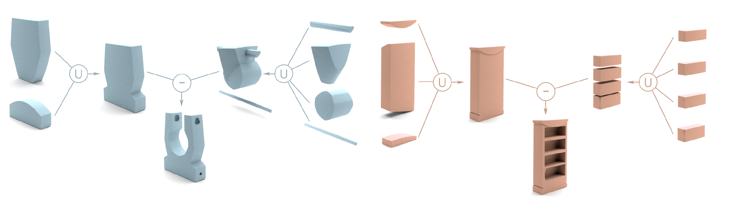

# Topic 2. Generation

* (Random Generation of 3D Models) GET3D: A Generative Model of High Quality 3D Textured Shapes Learned from Images.

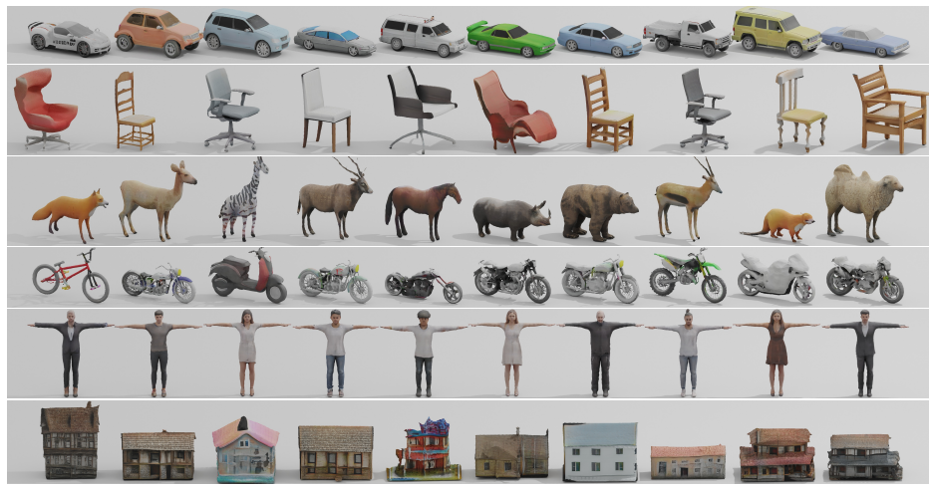

* (Random Generation of Floorplans) Jiahui Sun, Wenming Wu, Ligang Liu, Wenjie Min, Gaofeng Zhang, Liping Zheng: WallPlan: synthesizing floorplans by learning to generate wall graphs. ACM Trans. Graph. 41(4): 92:1-92:14 (2022)

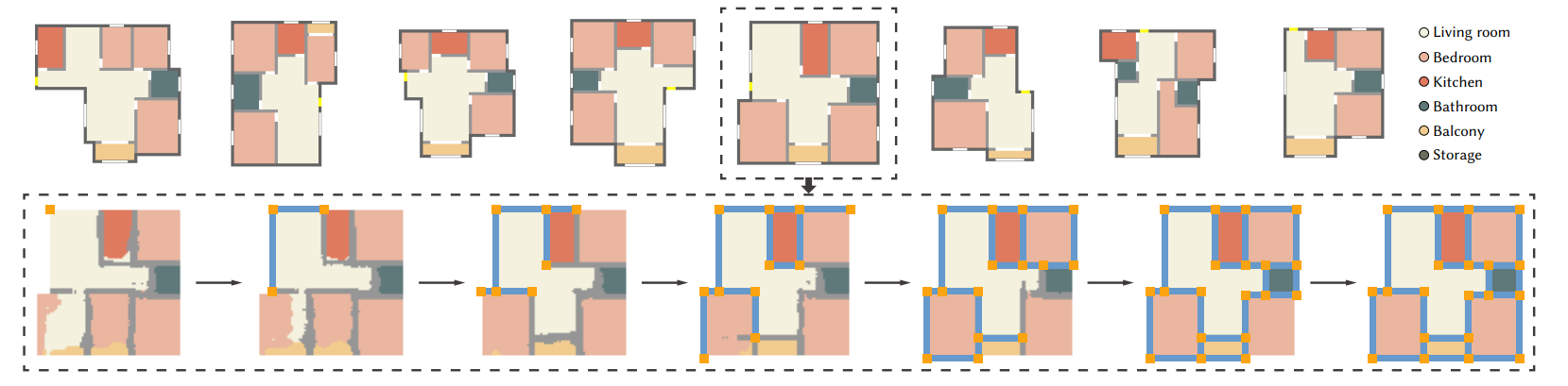

* (Scene Generation from a Given Story) Changyang Li, Wanwan Li, Haikun Huang, Lap-Fai Yu: Interactive augmented reality storytelling guided by scene semantics. ACM Trans. Graph. 41(4): 91:1-91:15 (2022)

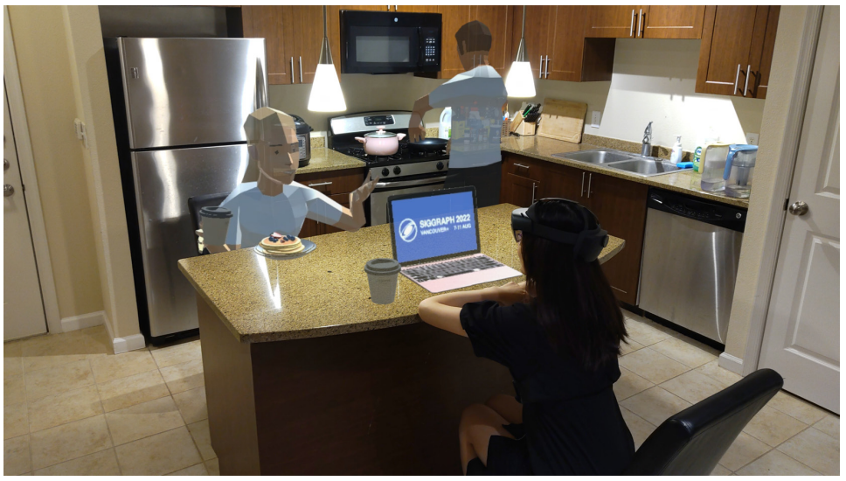

* (Text-to-3D) DREAMFUSION: TEXT-TO-3D USING 2D DIFFUSION

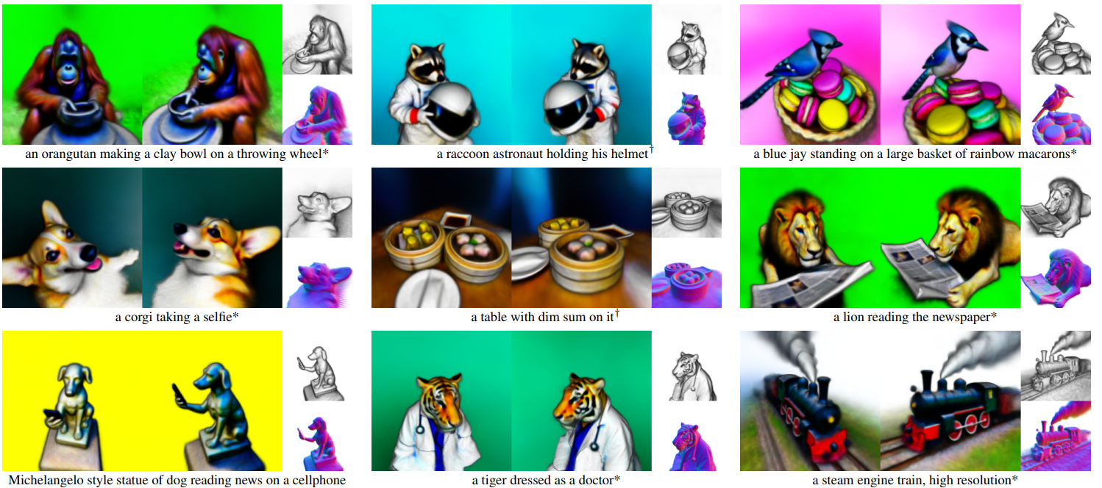

* (Text-to-Video) Make-A-Video: Text-to-video Generation without text-video data

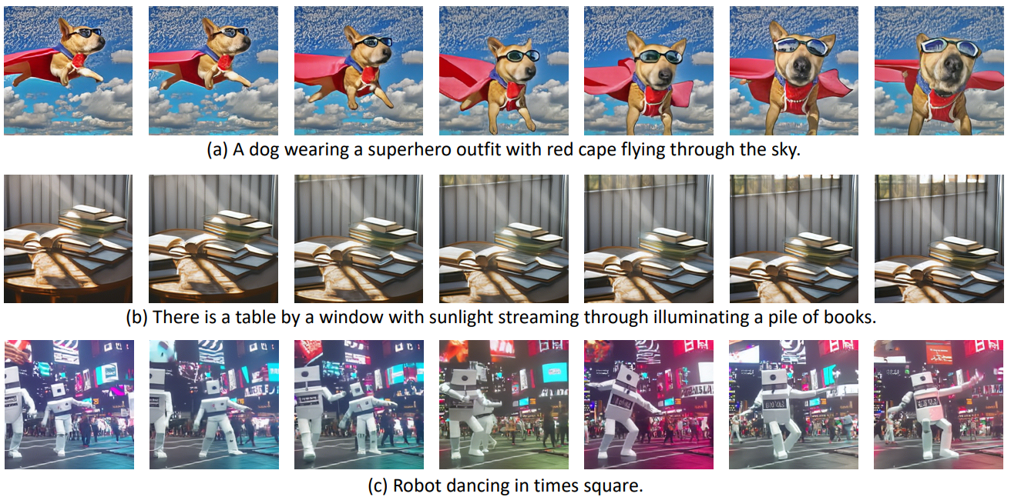

* (Text-to-Mesh) Oscar Michel, Roi Bar-On, Richard Liu, Sagie Benaim, Rana Hanocka: Text2Mesh: Text-Driven Neural Stylization for Meshes. CVPR 2022: 13482-13492

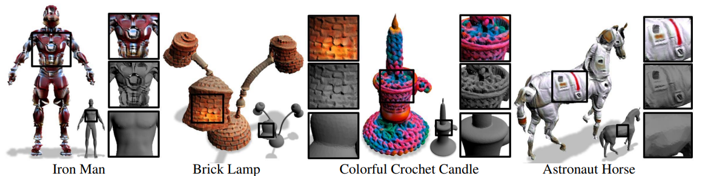

* (Motion Synthesis from a Single Sample) Peizhuo Li, Kfir Aberman, Zihan Zhang, Rana Hanocka, Olga Sorkine-Hornung: GANimator: neural motion synthesis from a single sequence. ACM Trans. Graph. 41(4): 138:1-138:12 (2022)

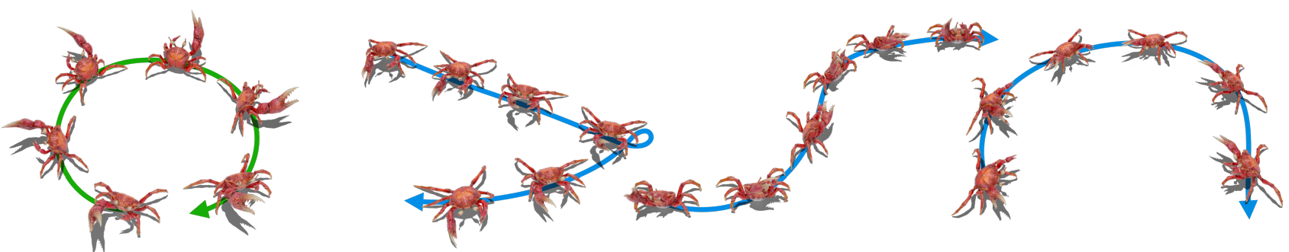

# Topic 3. Rendering:

* (Neural Rendering of Radiance Fields) Ben Mildenhall, Pratul P. Srinivasan, Matthew Tancik, Jonathan T. Barron, Ravi Ramamoorthi, Ren Ng: NeRF: Representing Scenes as Neural Radiance Fields for View Synthesis. ECCV (1) 2020: 405-421

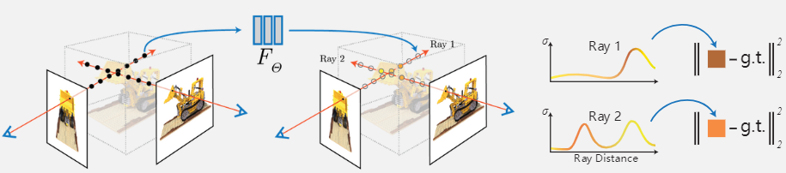

* (Neural Rendering of Disentangled Geometry and Appearance) Fanbo Xiang, Zexiang Xu, Milos Hasan, Yannick Hold-Geoffroy, Kalyan Sunkavalli, Hao Su: NeuTex: Neural Texture Mapping for Volumetric Neural Rendering. CVPR 2021: 7119-7128

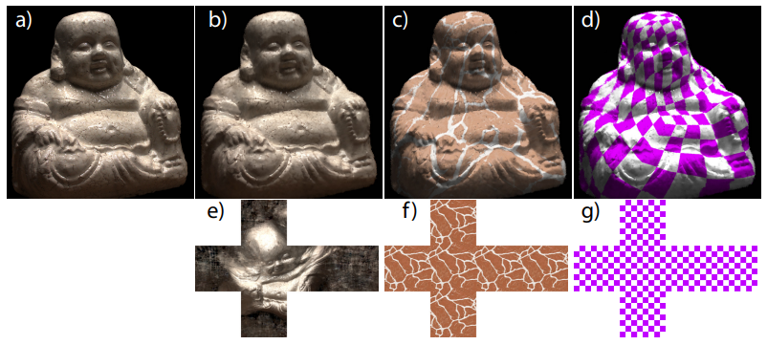

* (Fur Rendering) Junqiu Zhu, Sizhe Zhao, Lu Wang, Yanning Xu, Ling-Qi Yan: Practical level-of-detail aggregation of fur appearance. ACM Trans. Graph. 41(4): 47:1-47:17 (2022)

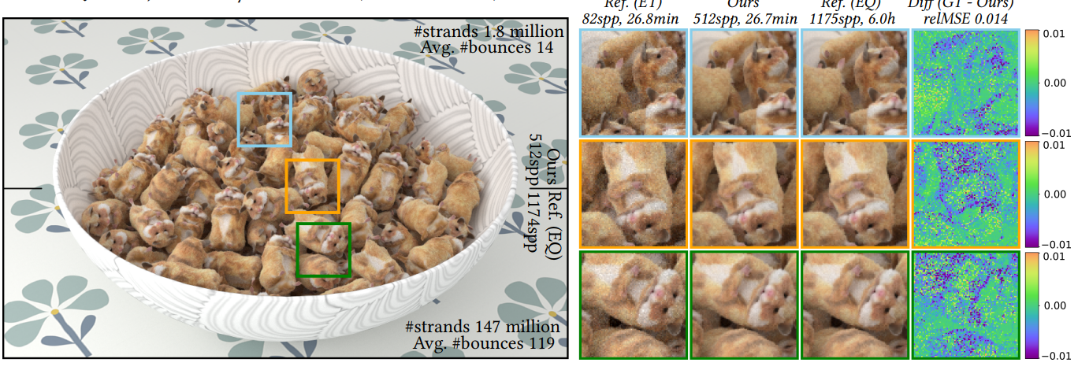

* (Material Generation, Adobe’s Work) Paul Guerrero, Milos Hasan, Kalyan Sunkavalli, Radomír Mech, Tamy Boubekeur, Niloy J. Mitra: MatFormer: a generative model for procedural materials. ACM Trans. Graph. 41(4): 46:1-46:12 (2022)

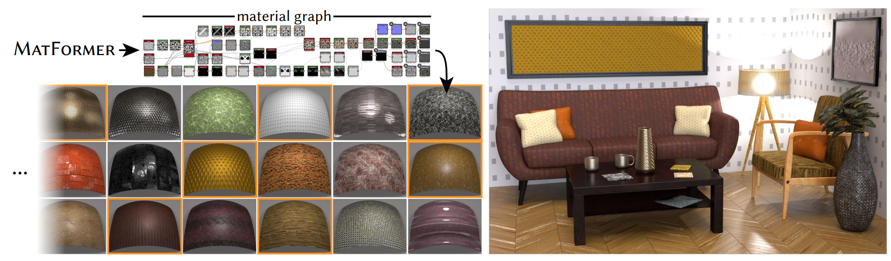

* (Scene Rendering) Xiuchao Wu, Jiamin Xu, Zihan Zhu, Hujun Bao, Qixing Huang, James Tompkin, Weiwei Xu: Scalable neural indoor scene rendering. ACM Trans. Graph. 41(4): 98:1-98:16 (2022)

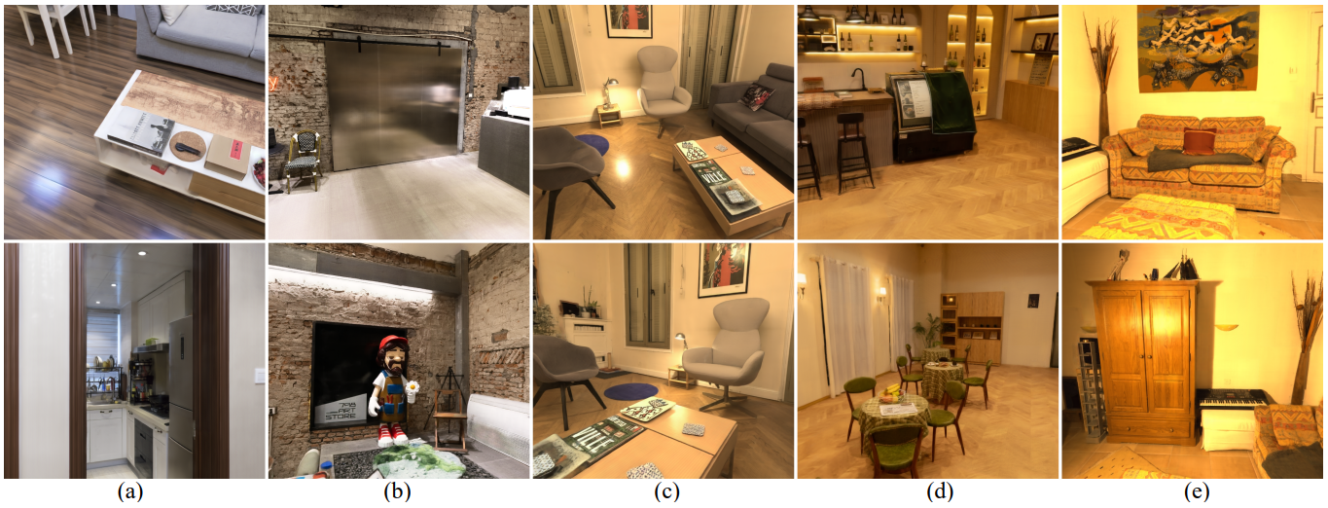

* (Scene Rendering) Bangbang Yang, Yinda Zhang, Yijin Li, Zhaopeng Cui, Sean Fanello, Hujun Bao, Guofeng Zhang: Neural rendering in a room: amodal 3D understanding and free-viewpoint rendering for the closed scene composed of pre-captured objects. ACM Trans. Graph. 41(4): 101:1-101:10 (2022)

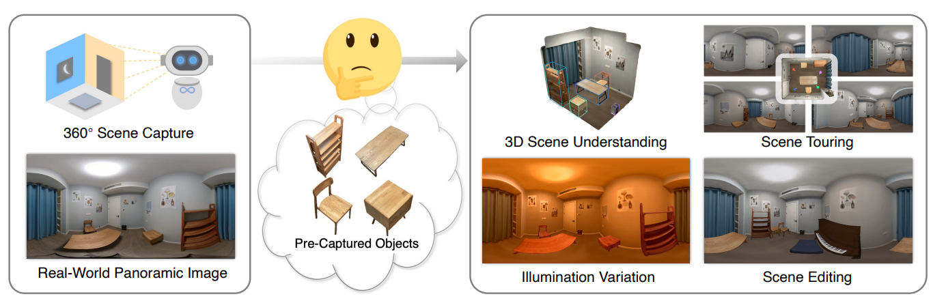

# Topic 4. Human modeling

* (Human Body Generation from Text) Fangzhou Hong, Mingyuan Zhang, Liang Pan, Zhongang Cai, Lei Yang, Ziwei Liu: AvatarCLIP: zero-shot text-driven generation and animation of 3D avatars. ACM Trans. Graph. 41(4): 161:1-161:19 (2022)

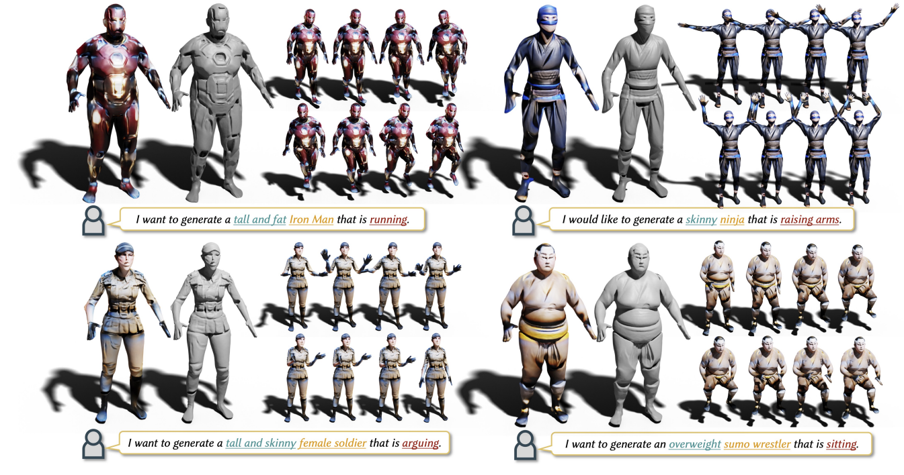

* (Human Body Reconstruction from Images) Shunsuke Saito, Zeng Huang, Ryota Natsume, Shigeo Morishima, Hao Li, Angjoo Kanazawa: PIFu: Pixel-Aligned Implicit Function for High-Resolution Clothed Human Digitization. ICCV 2019: 2304-2314

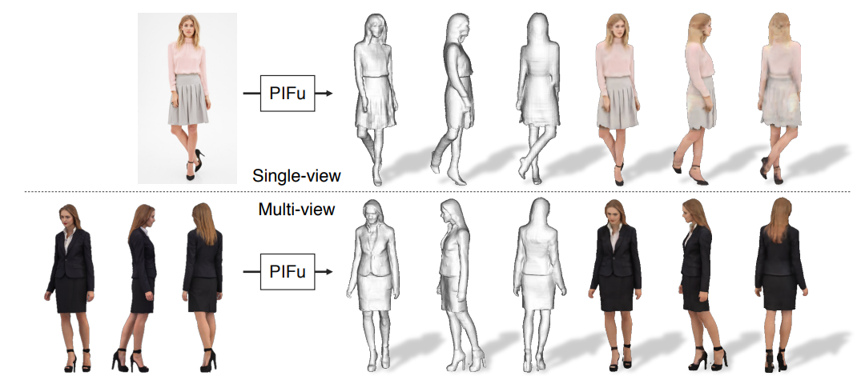

* (Human Body Reconstruction from Videos) Animatable Neural Implicit Surfaces for Creating Avatars from Videos

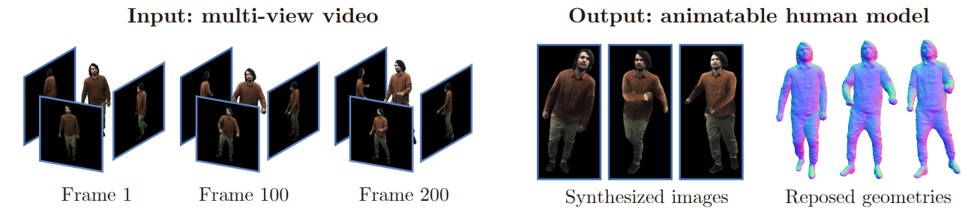

* (Human Hand Modeling) Yuwei Li, Longwen Zhang, Zesong Qiu, Yingwenqi Jiang, Nianyi Li, Yuexin Ma, Yuyao Zhang, Lan Xu, Jingyi Yu: NIMBLE: a non-rigid hand model with bones and muscles. ACM Trans. Graph. 41(4): 120:1-120:16 (2022)

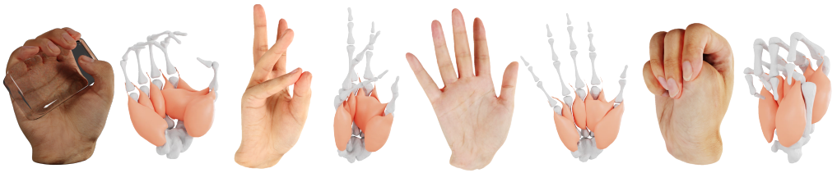

* (Human Face Modeling) Ling J, Wang Z, Lu M, et al. Semantically Disentangled Variational Autoencoder for Modeling 3D Facial Details[J]. IEEE Transactions on Visualization and Computer Graphics, 2022.

# Topic 5. Animation and Interaction

* (Hand Grasp) Zhu T, Wu R, Lin X, et al. Toward human-like grasp: Dexterous grasping via semantic representation of object-hand[C]//Proceedings of the IEEE/CVF International Conference on Computer Vision. 2021: 15741-15751.

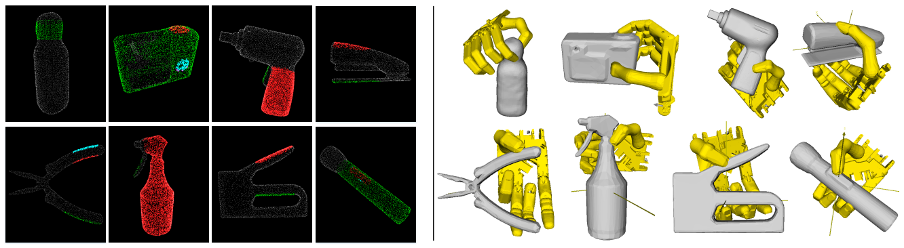

* (Hand Animation) Zeshi Yang, KangKang Yin, Libin Liu: Learning to use chopsticks in diverse gripping styles. ACM Trans. Graph. 41(4): 95:1-95:17 (2022)

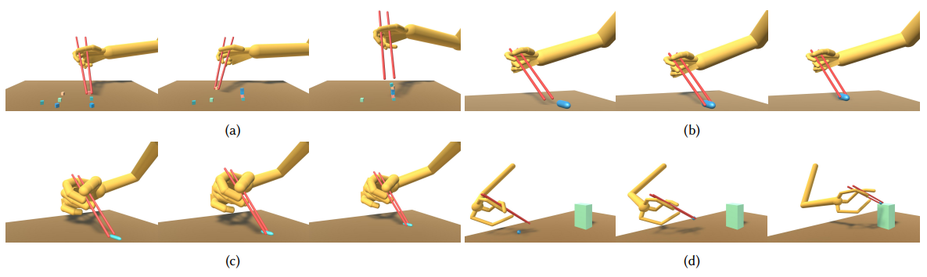

* (Dance Synthesis) Yinglin Duan, Tianyang Shi, Zhipeng Hu, Zhengxia Zou, Changjie Fan, Yi Yuan, Xi Li: Automatic Translation of Music-to-Dance for In-Game Characters. IJCAI 2021: 2344-2351

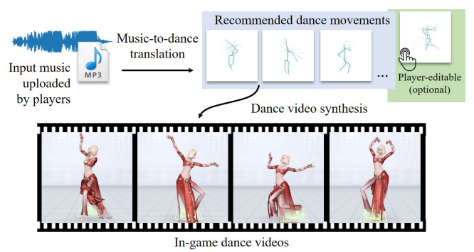

* (Scene Arrangement Policy) Hanqing Wang, Wei Liang, Lap-Fai Yu: Scene mover: automatic move planning for scene arrangement by deep reinforcement learning. ACM Trans. Graph. 39(6): 233:1-233:15 (2020)

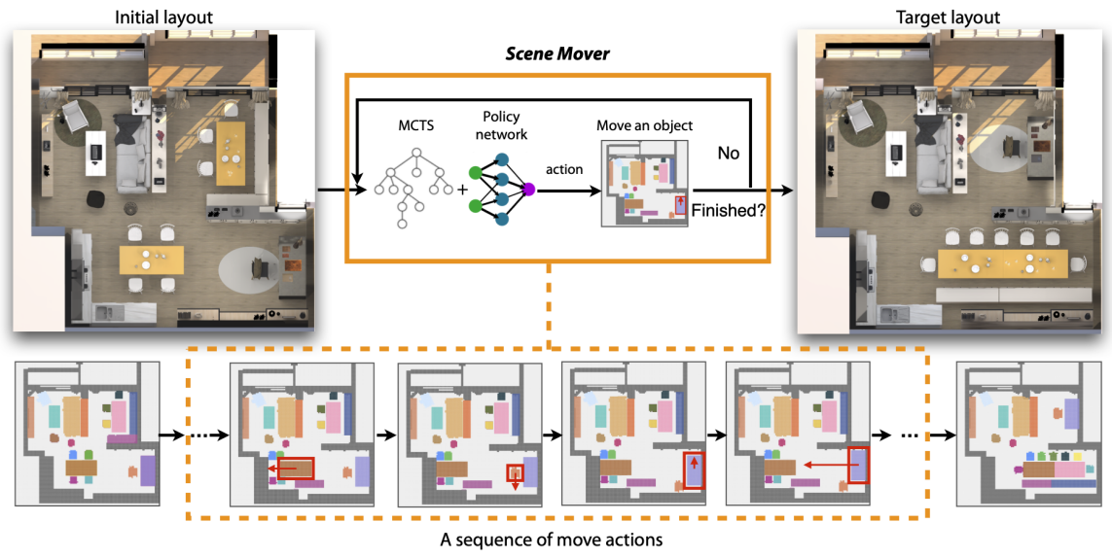

* (Activity-based Scene Design) Yongqi Zhang, Haikun Huang, Erion Plaku, Lap-Fai Yu: Joint computational design of workspaces and workplans. ACM Trans. Graph. 40(6): 228:1-228:16 (2021)

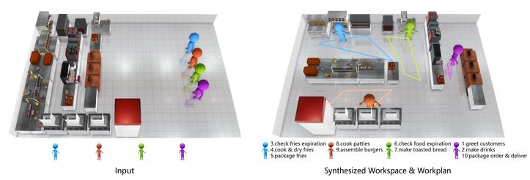

# Topic 6. Deep network for geometric processing

* (Point Cloud Understanding) Meng-Hao Guo, Junxiong Cai, Zheng-Ning Liu, Tai-Jiang Mu, Ralph R. Martin, Shi-Min Hu: PCT: Point cloud transformer. Comput. Vis. Media 7(2): 187-199 (2021)

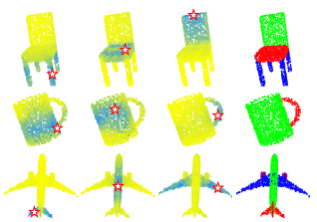

* (Mesh Understanding) Hu S M, Liu Z N, Guo M H, et al. Subdivision-based mesh convolution networks[J]. ACM Transactions on Graphics (TOG), 2022, 41(3): 1-16.

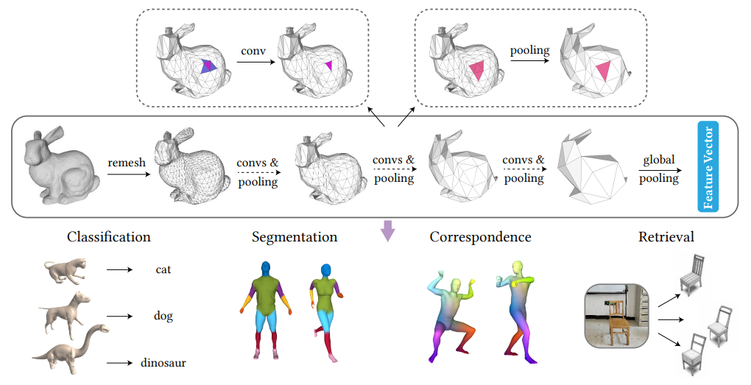

* (Point Cloud + RGB Fusion-based Detection) Sourabh Vora, Alex H. Lang, Bassam Helou, Oscar Beijbom: PointPainting: Sequential Fusion for 3D Object Detection. CVPR 2020: 4603-4611

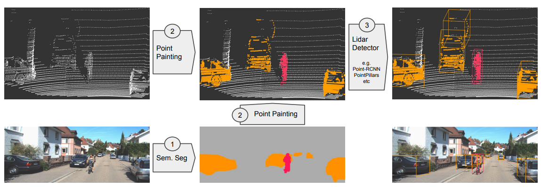

* (Edge Detection for CAD Models) Xiaogang Wang, Yuelang Xu, Kai Xu, Andrea Tagliasacchi, Bin Zhou, Ali Mahdavi-Amiri, Hao Zhang: PIE-NET: Parametric Inference of Point Cloud Edges. NeurIPS 2020

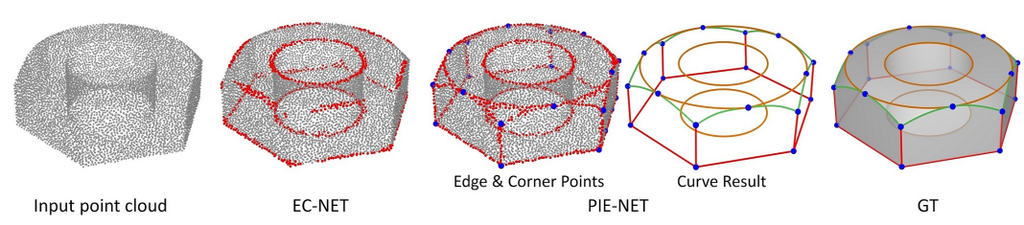

* (Shape-to-Codes) R. Kenny Jones, Aalia Habib, Rana Hanocka, Daniel Ritchie: The Neurally-Guided Shape Parser: Grammar-based Labeling of 3D Shape Regions with Approximate Inference. CVPR 2022: 11604-11613

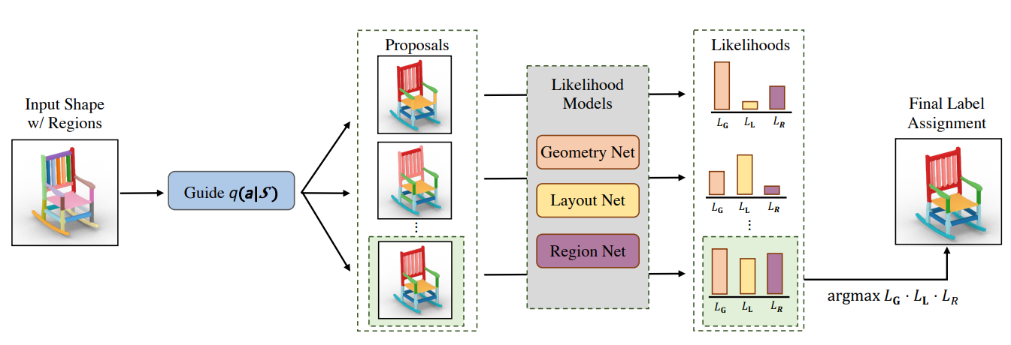

* (Subdivision) Hsueh-Ti Derek Liu, Vladimir G. Kim, Siddhartha Chaudhuri, Noam Aigerman, Alec Jacobson: Neural subdivision. ACM Trans. Graph. 39(4): 124 (2020)

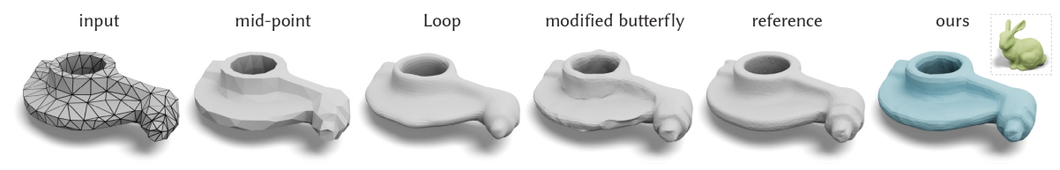

* (Deformation) Yifan Wang, Noam Aigerman, Vladimir G. Kim, Siddhartha Chaudhuri, Olga Sorkine-Hornung: Neural Cages for Detail-Preserving 3D Deformations. CVPR 2020: 72-80

